# Other contributions

## Index.html

Daire was given the task to create the index.html page. This involved writing all the corresponding HTML, CSS and JavaScript code. The dynamic sidebar that was already coded by another group member was also implemented into this page.

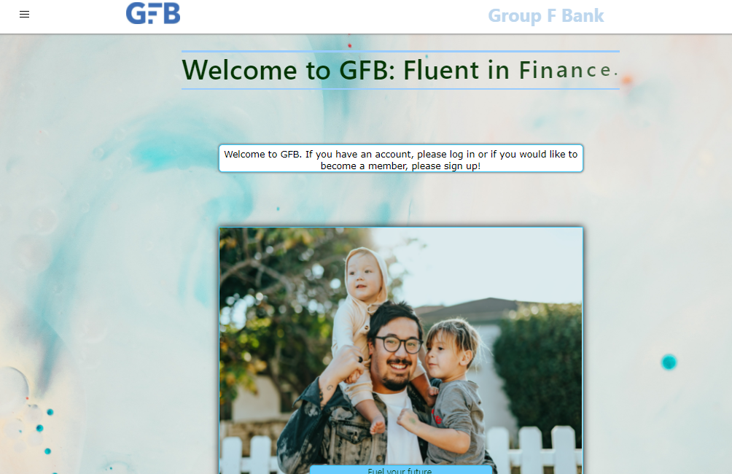

## adminPage.jsp

Daire also did the CSS styling on the *adminPage.jsp* for the display table.